

|  |
| --- |
| Solution Requirements Document |

All instructions for the use of this template are shown in this font.

**Showing and Hiding Instructions**

* To hide instructions, click the “ ¶” (show/hide) button,
* To display the instructions, click the “¶” (show/hide) button again.

Consider each section of the document, but only complete the sections that are applicable to your project. However, if a section is not applicable, please state so explicitly rather than deleting the section.

Risk-based Periodic Client Reviews

Phase 3 (Client Risk Profile, Automated Triggers and tracking Non-Compliant Clients)

Document Author: Hamid Yazdanpanah

Date of Issue: September 20, 2021

Document Version: V0.01

*{Draft}*

Table of Contents

1 Introduction 3

1.1 Purpose 3

1.2 User Description 3

1.3 Compliance with CIBC Technology Standards and Architecture 4

1.4 Business Context 4

1.5 Scope 4

1.5.1 In-Scope 4

1.5.2 Out of Scope 7

2 Assumptions, Dependencies & Constraints 7

2.1 Assumptions 7

2.2 Dependencies 7

2.3 Constraints 7

3 Functional Solution Requirements 8

3.1 Solution Requirements – Client Risk Profile 8

3.2 Solution Requirement – Automated Triggers 26

3.3 Solution Requirement – Closed Reviews 29

3.4 Solution Requirement – Wealth data 31

3.5 Solution Requirement – Misc 32

3.6 Non-Functional Requirements 32

4 Solution Requirements Documented Elsewhere 34

4.1 Use Cases List 34

4.2 Business Rules List 34

4.3 Messages List 34

4.4 Data Elements List 35

4.5 Non-Functional Solution Requirements List 35

4.6 User Interface Documents List 35

4.7 System to System Documents List 35

4.8 Other Documents List 35

5 Document Control 36

6 Appendices 37

Appendix A: Non-Personal Questionnaire – Screenshots 37

Appendix B: Internal-Facing EDD Forms – Screenshots 40

Appendix C: Sample of PDF Output files 45

Appendix D: Excel version of Client Risk Profile 45

Appendix E: List of material events in triggers 45

# Introduction

## 1.1 Purpose

Define the purpose of the Solution Requirements Document, including objectives and boundaries. The purpose may be related to the project’s purpose and objectives.

Example:

“The purpose of this document is to capture the Solution Requirements for all parties involved in the development of bill payment process using third-party merchants.”

The Solution Requirements Document (SRD) is used to capture detailed functional and non-functional requirements, use cases, messages, business rules, data elements, user interface design and other work products that may be used to describe solution requirements. In most cases, the Solution Requirements Document will ‘point’ to other documentation that captures further detail (such as Use Case documents).

Signoff of this Solution Requirements Document includes the detailed requirements defined in this document as well as:

* Associated Use Cases and Models
* Associated Business Rules
* Associated Messages
* Associated Data Elements
* Associated Non-Functional Solution Requirements
* Associated Report Requirements
* Associated System-to-System Interface Requirements

All associated documentation should be listed in the section “Solution Requirements Documented Elsewhere”.

The Solution Requirements Document, accompanied by all the applicable supporting documentation, is referred to as the Solution Requirements Package (SRP).

## 1.2 User Description

Primary user group for the Credit Risk Reports are as follows:

* CIBC First Caribbean Risk Services Team. (Team members to be identified during the project implementation phase.)
* CIBC First Caribbean Credit Risk Management Team (Team members to be identified during the project implementation phase.)<Describe the users and who the requirements are written for.>

## 1.3 Compliance with CIBC Technology Standards and Architecture

Solution shall comply with CIBC Technology Standards and Architecture. Otherwise, technology and business stakeholders must resolve discrepancies.

Refer to [Technology Standards](https://w3.cibc.com/sites/sbu/en/techops/tech/Pages/reference-guide-introduction.aspx) for more details on CIBC Technology Standards and Architecture.

## 1.4 Business Context <Describe what is in and out of scope from the Solution Requirements perspective. Do not repeat the scope of the project, just reference the Project Charter for that information. Anything not covered in this section is out of scope by default.>

## 1.5 Scope<Describe what is in and out of scope from the Solution Requirements perspective. Do not repeat the scope of the project, just reference the Project Charter for that information. Anything not covered in this section is out of scope by default.>

### 1.5.1 In-Scope

The scope of this document is limited to the following:

* Client Risk Profile
* Automated triggers for certain material events/changes
* Tracking the client reviews that are Completed but Non-Compliant (objective to have them Compliant) – “Closed reviews”
* Integration with mCIF to access Wealth data
* Sending the CIF form by email within PCR

Items from Phase 2:

* CRR calculation of High Risk for Non-Personal --
* NFR#02 implement the Support and Administration roles--

| **Header** | **In Scope** |
| --- | --- |
| **Territories** | All Territories:   1. Antigua 2. Aruba 3. Bahamas 4. Barbados 5. British Virgin Islands 6. Cayman Islands 7. Curacao 8. Dominica 9. Grenada 10. Jamaica 11. St. Kitts & Nevis 12. St. Lucia 13. St. Maarten 14. St. Vincent 15. Trinidad 16. Turks & Caicos Islands |
| **Business Segments & units** | 1. RETAIL, Business Banking (RET & BB) 2. CORPORATE Banking (CORP) 3. WEALTH (LOB’s):    * International Corporate Banking    * Private Banking    * Barbados Asset Management    * Curacao Investment Advisory    * Investment Advisory    * Bahamas Trust 4. COMPLIANCE   ***Foot Notes:***   1. *Each Wealth Sub-Segment is further broken down into business service units. Below, units under Cayman Bank & Trust, similar units under other sub-segments:*    * *Trust Services,*    * *Fund Administration,*    * *Securities Investment Business.*    * *subsidiary - CIBC Fund Administration Services (Asia) Limited* |
| **Customers** | 1. Personal 2. Non-Personal |
| **Systems** | **RETAIL / CORP / WEALTH (a) – Shared Systems:**   1. Signature (ICBS) 2. Digital Client File (DCF)   **WEALTH Systems:**   1. ~~Pershing (NetX360 Platform) – Wealth (Investment Advisory)~~ 2. ~~Microgen 5Series – Wealth (Bahamas Trust)~~ 3. ~~FlexCube (FCC) – Wealth (Curacao Wealth)~~ 4. mCIF as the book of record for Wealth data (g)   **CORPORATE System:**   1. RELY (Customer Leasing – Trinidad) (b) 2. iCAP (Corporate Credit Adjudication & Processing) 3. BizApp (commercial credit applications for Small Business clients)   **RISK MANAGEMENT Systems**:   1. Client Risk Rating (CRR) Service (c ) 2. Compliance Screening Portal (d)    1. FircosSoft (e )    2. World-Check database (f )   ***Foot Notes:***   1. *International Corporate Banking & Private Banking* 2. *Supports ICBS CIF, tied into Rely Accounts) (vendor - Nova Base)* 3. *CRR Service – Developed as Enterprise Service under DCO Program, in production. Supports Non-Personal Compliance requirements. Requires enhancement to support Wealth Investment Advisory (IA) Business requirements personal & non-personal.* 4. *New portal, under AML Solution program, to provide users access to World Check & FircoSoft* 5. *FircoSoft - watch list filtering solutions – Sanctioning data* 6. *World-Check Database - Politically Exposed Persons (PEPs) and heightened risk individuals and organizations, used around the world to help to identify and manage financial, regulatory and reputational risk.* 7. *Once mCIF is ready, PCR will get the Wealth clients through mCIF and not via direct linking the systems.* |
| **Integration** | Integration with:   1. Risks Event Reporting (RER) 2. mCIF |

### 1.5.2 Out of Scope

| **Header** | **Out of Scope** |
| --- | --- |
| **Segments / Branch** | Sub-segment and Branch level access |
| **Integration** | Integration with:   1. FCRM (Financial Crime Risk Management) 2. Unusual Activity Reporting (UAR) vFire database |
|  | * Any requirements not listed in the scope section are considered out of scope. * Credit Card Clients without a CIF |
| **Misc.** | * The new AML KYC Compliant code |

<“Out of scope” describes the items you want to emphasize are out of scope.>

# Assumptions, Dependencies & Constraints

## Assumptions

* Business Stakeholders and SMEs will be available as required to provide input and decisions for project deliverables
* Dedicated technology and test resources will be available to develop design/build solution and carry out test plans per timelines for completion
* Contingency (backup resources/SMEs/expedited technology build) will be provided in the event of above assumptions not being met to adhere to overall project timelines
* The uploaded documents will be stored in the DCF system

* <Document the project “unknowns” and items that cannot be fully verified or available ahead of time. Note that most assumptions can be validated as either new requirements or dependencies. Work towards eliminating as many assumptions as possible.>

## Dependencies

* Project resource availability may be impacted due to competing projects and Business as Usual priorities
* CIRA document will outline material risks and mitigation strategy
* AML risk rating within the Core System/or on file for each client
* Access to the KYC compliance status of the Client and details on any KYC documents outstanding.
* Data feeds from Pershing and Microgen 5Series product systems, into FCIB DWH & EDP.

<Include major items (internal to project, external projects, business decisions, market environments, etc.) that are related in a way that will affect or defer requirement decisions. Dependencies are usually of a nature where something needs to be ‘started’ or ‘completed’ before a requirement can be defined.>

## Constraints

* Resource constraints within technology and required Business teams
* Potential conflict with other project implementations
* <Constraints are those regulatory, technology or business “realities” that legitimately constrain project delivery. This includes availability of project resources, project timeline expectations, hardware, facilities, equipment, regulatory approval, audit findings, etc.>

# Functional Solution Requirements

This section is used to document Functional Solution Requirements for the project.

The following describes the requirement attributes in the requirement definition table:

* **ID:** A unique identification number given to a requirement in order to make it traceable throughout the development process.
* **Description**: Provide details to explain the business requirement. It should be correct, feasible, prioritized within its section, unambiguous, verifiable and highlight any related requirements.
* **Business Priority:** Ranking of priority for the requirement:
* **H** = High = Critical and needs to be delivered within this phase;
* **M** = Medium = Seen as adding value to the offering and would be good to include within this phase;
* **L** = Low = Not critical to the delivery of the project and can be delivered at a later stage.
* **Requested By:** Used to document who and/or which area submitted the requirement.
* **Traceability:** the business or project objective, scope, constraints etc. from which this requirement was derived.

## Solution Requirements – Client Risk Profile

A centralized storage to host profiles and additional information on clients that provides Compliance with a holistic and readily available information.

<Define in this section Functional Solution Requirements that are not otherwise defined via Use Cases, Business Rules, Messages or User Interface documentation, as referenced in Section 3 of this document.

If Use Cases were NOT appropriate for this project, define all of the Functional Solution Requirements in this section.

A functional requirement is a system operation, or set of system operations, that must be met by the developed project solution.

Logically bundle the related requirements, as appropriate

Add sub-sections to capture the functional solution requirements as required.>

| **ID** | **Description** | **\*** | **Specified By** | **Traceable from** |
| --- | --- | --- | --- | --- |
| 3.1.1 | The PCR tool should provide the ability to input information related to Client Risk Profile for a client. | H |  |  |
| 3.1.2 | The solution should have the ability to create the following two forms:   * Non-Personal Questionnaire * Internal-Facing EDD form   Refer to Appendix D for the Excel version of Client Risk Profile. | H |  |  |
| 3.1.3 | The solution should have the ability to capture the following sections for Non-Personal Questionnaire form:   * Business information * Beneficial Ownership Information * Business Profile * Business Activity * Additional Information8 | H |  | 2 (For Skeleton) |

| 3.1.4 | The solution should have the ability to capture the following information in “Business information” section of Non-Personal Questionnaire form:  **Notes:**  *1. For Country use a dropdown list of countries.*  *2. For Mailing Address and Physical Address provide the ability to use the same address as Registered address.*  *3. Mandatory fields are highlighted in orange.*    For a sample screenshot refer to Appendix A |  |  | 5 days |
| --- | --- | --- | --- | --- |
|  | | | | |
| 3.1.5 | The solution should have the ability to present and capture the information of one to maximum five Beneficial Owner in “Beneficial Ownership information” section of Non-Personal Questionnaire form.  The information for each beneficial Owner is as follows:   * Full Legal Name * Residential Address * Birth Country * Citizenship Country * % Holding   **Notes:**  *1. For Country use a dropdown list of countries.*  *2. All the information are Mandatory (highlighted in orange)*  For a sample screenshot refer to Appendix A |  |  | 3 |
|  | | | | |

| 3.1.6 | The solution should have the ability to present and capture the following information in “Business Profile” section of Non-Personal Questionnaire form. |  |  | 5 |
| --- | --- | --- | --- | --- |
| |  |  |  | | --- | --- | --- | | **Title** | **Format** | **Note** | | *Do any of your Business' directors or owners hold or previously held public office with any government? If yes, kindly indicate the name of the person, the office held, and respective country/government*  *isOwnerheldPublicOffice.* | *Yes/No* |  | | *Name of Person:*  *BusinessProfilePersonname nvarchar(100)* | *Free text* | *Present the question only the above answer is Yes* | | *Describe the nature of Business*  *nVarchar(500)* | *Free Text* | *Mandatory* | | *What is the intended purpose of the account?*  *Purposeofaccount varchar(200)* | *Free Text* | *Mandatory* | | *Countries your Business currently trades with or intends to do business with*  *BusinessTradeInCountries* | *Maximum 5 Countries* | *Dropdown list of countries* | | *What kind of accounts are you interested in establishing?* | *Free text* |  | | *List the company's main trading counterparties:* | *Maximum of 10 Free text* | *At least one mandatory* | | *What is the estimated dollar amount in annual turnover at the company-level?* | *Free text* |  | | *Would your company require Cash Management Services?*  *(For example: Foreign Exchange, Merchant Services, Trade Finance, etc.)* | *Yes/No* |  |   For a sample screenshot refer to Appendix A | | | | |

| 3.1.7 | The solution should have the ability to present and capture the following information in “Business Activity” section of Non-Personal Questionnaire form. |  |  | 2.5 |
| --- | --- | --- | --- | --- |
| |  |  |  | | --- | --- | --- | | **Title** | **Format** | **Note** | | *1. a) Are you an agent of a Money Service Business (MSB) (e.g. Money Gram, Western Union, etc.)?* | *Yes/No* |  | | *2. Does your Business or its customers/clients manufacture, distribute, dispense or sell any type of marijuana or its by-products?* | *Yes/No* | *Present the question only the above answer is Yes* | | *3. Does your Business trade/engage in virtual/digital currencies, blockchain network or technology developed for this purpose?* | *Yes/No* |  | | *4. Does your Business operate as a casino or engage in gaming (poker, video/machines gaming dealing, etc.?)* | *Yes/No* |  | | *5. a) Does your Business perform Third Party Transactions (conduct transactions on your account on behalf of another party) for customers/clients?* | *Yes/No* |  | | *' b) Does your Business have an AML/CTF policy/program?* | *Yes/No* | *Present the question only if the answer to question 5. is Yes* |   For a sample screenshot refer to Appendix A | | | | |
| 3.1.8 | The solution should have the ability to capture Additional Information as a free text in Non-Personal Questionnaire form.  For a sample screenshot refer to Appendix A |  |  | 0.5 |
| 3.1.9 | The solution should have the ability to capture the following sections for Internal-Facing EDD form:   * Client Information * Account Information * Client Background * Business Decision & Controls |  |  | 2 (Only Skeleton) |
| 3.1.10 | The solution should have the ability to present and capture the following information in “Client Information” section of Internal-Facing EDD Form:   |  |  | | --- | --- | | **Title** | **Note** | | *Client Name:* | *Sourced from Non-Personal Questionnaire* | | *Type of Client:* | *Mandatory* | | *Type of Business:* | *Sourced from Non-Personal Questionnaire* | | *Date of Incorporation / Birth:* | *Sourced from Non-Personal Questionnaire* | | *Location of Head Office:* | *Sourced from Non-Personal Questionnaire*  *(Street Address, Town, Province, Country)* | | *Country of Incorporation:* | *Sourced from Non-Personal Questionnaire* | | *RM Name & Post #:* | *Mandatory* | | *CIF Number:* | *Mandatory* | | *Transit Number:* | *Mandatory* | | *Credit Risk Rating (if applicable):* | *Mandatory (it should state N/A if not applicable)* |   For a sample screenshot refer to Appendix B |  |  | 4 |
| 3.1.11 | The solution should have the ability to present and capture the following information of one to maximum 10 Accounts in “Account information” section of Internal-Facing EDD Form.  The information for each Account is as follows:   |  |  | | --- | --- | | **Title** | **Note** | | *Client Account Opening Date:* | *Mandatory* | | *Account Number:* | *Mandatory* | | *High-Risk Identifiers (if applicable):* | *Mandatory* | | *Purpose of Account:* | *Mandatory* | | *Source of Funds:* | *Mandatory* | | *Funds Flows (per month and per year)*  *\* No of Forecasted Transactional Activity*  *\* Dollar amount of Forecasted Transactional Activity* | *Mandatory* |   For a sample screenshot refer to Appendix B |  |  | 3 |

| 3.1.12 | The solution should have the ability to present and capture the following information on “Client Background” section of Internal-Facing EDD Form. |  |  |  |
| --- | --- | --- | --- | --- |
| |  |  |  | | --- | --- | --- | | **Title** | **Format** | **Note** | | *Provide business overview (refer to notes under ‘What is Required’ to complete):* | *Free text* | *Mandatory* | | *Outline key suppliers and trading partners (consider if well-known counterparties and reasonable for the business conducted):*  *Note: If you enter data into the field and then change the fields in List the company's main trading counterparties: on the 'CIB Questionnaire tab', your changes to this field will be lost* | *Free text* | *Prepopulate with List the company's main trading counterparties: on the 'CIB Questionnaire tab'* | | *Provide assessment of sales &/or projected sales (consider daily, weekly or monthly cash deposits – estimated and actual):* | *Free text* | *Mandatory* | | *Detail cash and deposit activity or projected activity in conjunction with review of financial statements and provide assessment of reasonableness (Analyze daily cash/deposit inflows using ICBS, course of accounts and other available reports over minimum six month period ; consider seasonal activity/business expansion /location changes/frequency of deposits in analysis):* | *Free text* |  | | *Provide assessment whether any unusual activity revealed in customer’ transactions. Outline if any UARs filed and action taken (consider if any negative news or reputational considerations exist and whether a UAR is warranted.):* | *Free text* |  | | *EDD Trigger*   * *Political Exposed Persons (Domestic or Foreign)* * *Clients with Sanctioned or Restricted Rating* * *Persons or Entities Operating Physical Gambling Locations* * *Pooled Account and Accounts Opened for or on the Behalf of Third Parties* * *Service Providers and Citizens under Citizen by Investment or Similar Programs* * *Persons or Entities from Countries Deemed to have AML / ATF Deficiencies or High-Risk Countries (see List of Sanctioned, Restricted Countries & Prohibited Entities)* * *Persons Linked to Argentina or Venezuela* * *Persons Linked to Panama* * *Businesses that Deal with High Volumes of Cash (Cash-Intensive or Cash-Based Businesses)* * *Correspondent Banking Relationships* * *Grandfathered MSBs* * *Embassies* * *Non-Profit Organizations (NPOs)* * *Micro-Lending Businesses* | *Checklist* | *Refer to the following requirements for the details* |   For a sample screenshot refer to Appendix B | | | | |
| 3.1.13 | The solution should have the ability to present the EDD Trigger checklist including the following items on “Client Background” section of Internal-Facing EDD Form and expand the section related to the selected item(s) from the checklist to present and capture the associated data elements.   * *Political Exposed Persons (Domestic or Foreign)* * *Clients with Sanctioned or Restricted Rating* * *Persons or Entities Operating Physical Gambling Locations* * *Pooled Account and Accounts Opened for or on the Behalf of Third Parties* * *Service Providers and Citizens under Citizen by Investment or Similar Programs* * *Persons or Entities from Countries Deemed to have AML / ATF Deficiencies or High-Risk Countries (see List of Sanctioned, Restricted Countries & Prohibited Entities)* * *Persons Linked to Argentina or Venezuela* * *Persons Linked to Panama* * *Businesses that Deal with High Volumes of Cash (Cash-Intensive or Cash-Based Businesses)* * *Correspondent Banking Relationships* * *Grandfathered MSBs* * *Embassies* * *Non-Profit Organizations (NPOs)* * *Micro-Lending Businesses* |  |  |  |

| 3.1.14 | The solution should have the ability to present and capture the associated data elements for one to maximum of five individual’s information when “Political Exposed Persons (Domestic or Foreign)” is selected from the EDD Trigger checklist. |  |  | 6|8 |
| --- | --- | --- | --- | --- |
| **Notes:**  *1. For Country use a dropdown list of countries.*  *2. All the information are Mandatory (highlighted in orange)* | | | | |
| 3.1.15 | The solution should have the ability to present and capture the following associated data elements when “Clients with Sanctioned or Restricted Rating” is selected from the EDD Trigger checklist.   * *Please provide rationale for Client having Sanctioned or Restricted Rating (Mandatory, Free text)* * *Approval from Compliance Sanctions*   *Provide reason for hit, date of notification and approval, where applicable (Mandatory, Free text)*  For a sample screenshot refer to Appendix B |  |  | 3 or 4 |
| **Notes:**  *1. All the information are Mandatory (highlighted in orange)* | | | | |
| 3.1.16 | The solution should have the ability to present and capture the following associated data elements when “Persons or Entities Operating Physical Gambling Locations” is selected from the EDD Trigger checklist.   * *Please provide more information regarding Client's Operation of Physical Gambling Locations (Mandatory, Free text)*   For a sample screenshot refer to Appendix B |  |  | 1 |

| 3.1.17 | The solution should have the ability to present and capture the following associated data elements when “Pooled Account and Accounts Opened for or on the Behalf of Third Parties” is selected from the EDD Trigger checklist. |  |  | 5 or 7 |
| --- | --- | --- | --- | --- |
| **Notes:**  *1. Present “Regulatory Authority” and “Date last Assessed” only if the answer to “Is client a regulated Entity” is Yes?*  *2. All the information are Mandatory (highlighted in orange)* | | | | |
| 3.1.18 | The solution should have the ability to present and capture the following associated data elements when “Service Providers and Citizens under Citizen by Investment or Similar Programs” is selected from the EDD Trigger checklist.   * *Please provide more information regarding Client's participation in a Citizen by Investment or similar program (Mandatory, Free text)*   For a sample screenshot refer to Appendix B |  |  | 1 |
| 3.1.19 | The solution should have the ability to present and capture the following associated data elements when “Persons or Entities from Countries Deemed to have AML / ATF Deficiencies or High-Risk Countries (see List of Sanctioned, Restricted Countries & Prohibited Entities)” is selected from the EDD Trigger checklist.   * Please provide more information regarding Client's participation in a Citizen by Investment or similar program   For a sample screenshot refer to Appendix B |  |  | 1 |
| 3.1.20 | The solution should have the ability to present and capture the following associated data elements when “Persons Linked to Argentina or Venezuela” is selected from the EDD Trigger checklist.   * *Please provide rationale for flagging Client being linked to Argentina or Venezuela (Mandatory, Free text)*   For a sample screenshot refer to Appendix B |  |  | 1 |
| 3.1.21 | The solution should have the ability to present and capture the following associated data elements when “Persons Linked to Panama” is selected from the EDD Trigger checklist.   * *Please provide rationale for flagging Client being linked to Panama (Mandatory, Free text)*   For a sample screenshot refer to Appendix B |  |  | 1 |
| 3.1.22 | The solution should have the ability to present and capture the following associated data elements when “Businesses that Deal with High Volumes of Cash (Cash-Intensive or Cash-Based Businesses)” is selected from the EDD Trigger checklist.   * *Please any further rationale for designation as ‘Cash-Intensive’ or ‘Cash-Based’ Business (Mandatory, Free text)*   For a sample screenshot refer to Appendix B |  |  | 1 |
| 3.1.23 | The solution should have the ability to present and capture the following associated data elements when “Correspondent Banking Relationships” is selected from the EDD Trigger checklist.   * *Please provide rationale for flagging Client being linked to Panama (Mandatory, Free text)*   For a sample screenshot refer to Appendix B |  |  | 1 |
| 3.1.24 | The solution should have the ability to present and capture the following associated data elements when “Grandfathered MSBs” is selected from the EDD Trigger checklist.   * *Please provide rationale for flagging Client regarding grandfathered MSBs (Mandatory, Free text)*   For a sample screenshot refer to Appendix B |  |  | 1 |
| 3.1.25 | The solution should have the ability to present and capture the following associated data elements when “Embassies” is selected from the EDD Trigger checklist.   * *Please provide information regarding Client’s involvement with embassies (Mandatory, Free text)*   For a sample screenshot refer to Appendix B |  |  | 1 |
| 3.1.26 | The solution should have the ability to present and capture the following associated data elements when “Non-Profit Organizations (NPOs)” is selected from the EDD Trigger checklist.   * *Please provide rationale for flagging Client being linked to Panama (Mandatory, Free text)*   For a sample screenshot refer to Appendix B |  |  | 1 |
| 3.1.27 | The solution should have the ability to present and capture the following associated data elements when “Micro-Lending Businesses” is selected from the EDD Trigger checklist.   * *Please provide rationale for flagging Client as a Micro-Lending Business or as involved with Micro-Lending Businesses (Mandatory, Free text)*   For a sample screenshot refer to Appendix B |  |  | 1 |

| 3.1.28 | The system must provide the following hierarchy for approval workflow:   * Manager’s Review * Cluster Head Approval * Final Approval   ***Note:*** *Each level needs the approval of the previous level to proceed.* |  |  |  |
| --- | --- | --- | --- | --- |
| 3.1.29 | The system should capture the following information for each level of approval:   * Approver / Reviewer's Name * Approval Email (embedded) * Date Approved * Notes |  |  | 3 |
| 3.1.30 | The solution should have the ability to present and capture the following information on “Business Decisions & Control” section of Internal-Facing EDD Form. |  |  | 5 |
| |  |  |  | | --- | --- | --- | | **Title** | **Format** | **Note** | | *Rationale for Onboarding/Continuing Relationship* | *Free text* | *Mandatory* | | *Controls to Mitigate Risk*  *Example enhanced oversight, verification of source of funds, more frequent reviews, reference checks etc.* | *Free text* | *Mandatory* | | *Additional Information* | *Free text* | *Mandatory* | | *Attached Documentation*  *Attached documents (list of all documents received and searches conducted - refer to Client information standard, regional supplement & EDD Guidelines):* | *Free text* | *One to maximum of 10 rows to attach documents.* | | *Manager’s Review:*   * *Approver / Reviewer's Name* * *Approval Email (embedded)* * *Date Approved* * *Notes* |  |  | | *Cluster Head Approval:*   * *Approver / Reviewer's Name* * *Approval Email (embedded)* * *Date Approved* * *Notes* |  |  | | *Final Approval:*   * *Approver / Reviewer's Name* * *Approval Email (embedded)* * *Date Approved* * *Notes* |  |  |   For a sample screenshot refer to Appendix B | | | | |
| 3.1.31 | The solution should provide the ability to manually generate the following two PDF format output files at any time:   * Non-Personal Questionnaire * Internal-Facing EDD form   **Note:** ***Any missing mandatory*** should be highlighted in orange.  For a sample of PDF output file refer to Appendix C |  |  | 8 |

## Solution Requirement – Automated Triggers

There are a number material events occurring with a client to flag them for conducting a review. Some of the events can automatically trigger a review. It is also possible for a staff to manually flag a client for review at their discretion.

| **ID** | **Description** | **\*** | **Specified By** | **Traceable from** |
| --- | --- | --- | --- | --- |
| 3.2.1 | The solution should provide the ability to have the following two types of reviews:   * Partial Review * Full Review | H |  | 8 |
| 3.2.2 | The solution should implement Partial Review which consists of:   * KYC checks and reviews * Compliance Screen Check |  |  |  |
| 3.2.3 | The solution should implement Full Review which consists of:   * KYC checks and reviews * Compliance Screen Check * the review of the individual/associated accounts |  |  |  |
| 3.2.4 | The solution should provide the ability to change the Next Review date and trigger to pull up a CIF Maintenance only for Full Review.  **Note:** Partial review should not change the next review date nor pull up a CIF Maintenance form |  |  |  |
| 3.2.5 | The solution should automatically flag a client for a Full Review if one of the following material events/changes occur:   * Change in the Client risk rating * Change in the level of ML/TF risk for any customer where directed by Compliance due to a change in the AML/ATF Risk Rating Matrix * Where a Risk Event report was completed * Dormant accounts that are being reactivated * A change in the Client’s name (including changes resulting from the addition or deletion of an Account holder) or a change in the name in which the Account is maintained * A change of a Director or Signing Officer on the Account, including where the Signing Officer is added by virtue of granting of Power of Attorney on an Account, or where the estate representative takes over control of the assets of a deceased individual and becomes a Signing Officer on an Account as a result; * A change/addition of a Beneficial Owner(s) of an Account (Personal or Non-Personal)   For a list of all Material events refer to Appendix E. |  |  | 10 |
| 3.2.6 | The solution should notify the RM (Relationship Manager) and/Reviewer when a client is automatically flagged for review. |  |  |  |
| 3.2.7 | For the trigger identified as “where a Risk Event report was completed”, the solution should provide the ability to let the reviewer to decide to continue with the review or decide that the review is not required. |  |  | 3 |
| 3.2.8 | The solution should provide the ability to automatically flag a client for a Partial Review if one of the following material events/changes occur:   * The purchase of a new product or attainment of a service by an existing client   Product can be opening of a new account  Service can be granting of a credit increase   * Change of residential address outside of country (material change) (also FATCA trigger)   For a list of all Material events refer to Appendix E. |  |  | 6 |
| 3.2.9 | The solution should provide the ability for manual review (adhoc review) of a client if one of the following material events/changes occur:   * A transaction which involves or exceeds the prescribed amount and is a material change in the manner in which the account is operated ( applicable to Jamaica); * Where transactions conducted appear to be linked (applicable to Jamaica); and m) Where a transaction is conducted via wire transfer ( applicable to Jamaica) * Whenever the LoB has any reason to question the veracity, accuracy, adequacy or currency of any information previously obtained regarding the Client; * Where unusual activity have been noted and reported on an account; (red flag, other than normal activity) * Where there is a significant change in the way the client account is operated that is not consistent with the client profile. * If the aggregate amount exceeds the potential activity (inclusive of parameters e.g. 25% consistently over) * A noticeable or significant increase in the activity on the account e.g. increase in salary deposited (note that the Client profile should be updated to reflect change in account activity once verified); * Negative news and PEP * Customer classification (only if the change in Customer classification does not lead to Client Risk Rating change). |  |  | 3 |
| 3.2.10 | The solution should allow the reviewer to perform a Full review where a Partial Review is suggested. |  |  | 2 |
| 3.2.11 | The solution should allow the reviewer to perform a Partial review where a Full review is suggested and seek (and store) the approver’s approval. |  |  | 2 |
| 3.2.12 | The solution should provide the ability to nullify the request for a Full review if a Full review was performed recently (within the following time frame) for the client:   |  |  |  |  | | --- | --- | --- | --- | | Risk Rating | Wealth | Retail | Corporate | | 1 | 24 months | TBD | 24 months | | 2 | 24 months | TBD | 24 months | | 3 | 12 months | TBD | 12 months | | 4 | 12 months | TBD | 12 months | | 5 | 6 months | TBD | 6 months | |  |  |  |

## Solution Requirement – Closed Reviews

Reviews can be completed but remain non-Compliant. Once all the required documents are obtained and up-to-date, the review can be closed. PCR tool should provide the capability to track the steps to get a review closed meaning the review is both Complete and Compliant.

| **ID** | **Description** | **\*** | **Specified By** | **Traceable from** |
| --- | --- | --- | --- | --- |
| 3.3. | Provide an interface for all segments to process, track, monitor and report Non-Compliant clients. |  |  |  |
| 3.3. | Provide the functionality to track the steps associated with the action plan to procure outstanding items and obtain the required documents to ensure the client is Compliant. |  |  |  |
| 3.3. | The system must inform and notify business that the customer is Non-Compliant to allow them to request for updated and Compliant document to be obtained from the client. |  |  |  |
| 3.3. | The system must have a daily/weekly/monthly/periodically report that shows clients who are Non-Compliant to track the progress of obtaining new/updated documents. |  |  |  |
| 3.3. | All attempts to obtain a new document for Compliancy should be tracked for audit purposes. |  |  |  |
| 3.3. | The system must detect and record the date that a new document is requested from a customer. |  |  |  |
| 3.3. | The system must detect and record the date that a client is identified as Non-Compliant. |  |  |  |
| 3.3. | The system must be able to identify:   * The kind of document was received (a picklist of specific documents) * The information of the person evaluated the document * The result of the evaluation of the document * The date of the evaluation |  |  |  |
| 3.3. | The solution should provide the ability to carry an indication of whether or not the Client is Compliant or Non-Compliant. |  |  | Phase II – SRD  SR#3.1.29 |
| 3.3. | The solution should be able to prevent the generation of valid Certificate of Compliance for Non-Compliant clients. |  |  |  |
| 3.3. | The solution should be able to generate an escalation report on clients who remain Non-Compliant 90 days after being identified as Non-Compliant. |  |  |  |
|  |  |  |  |  |
|  |  |  |  |  |
|  |  |  |  |  |
|  |  |  |  |  |
|  |  |  |  |  |

## Solution Requirement – Wealth data

mCIF soon will have wealth data included and will be considered as book or record for wealth data.

| **ID** | **Description** | **\*** | **Specified By** | **Traceable from** |
| --- | --- | --- | --- | --- |
| 3.4.1 | The solution should be able to link PCR to mCIF to access Wealth data. |  |  |  |
|  |  |  |  |  |

## Solution Requirement – Misc

| **ID** | **Description** | **\*** | **Specified By** | **Traceable from** |
| --- | --- | --- | --- | --- |
| 3.5.1 | Provide the ability to the reviewers to send the CIF form by email within PCR (submit button) for approval.  **Note:**  As ‘CIF Update’ form is not tightly coupled with the review and approval process. Once CIF form will updated by reviewer using ‘CIF Update’ tab and converted to PDF then it should be attached and send to Manager for approval with approval email. |  |  | 3 |
| 3.5.2 | Upon approval by the supervisor/approver, Provide the ability to send the approved CIF form CIF Unit by email for further steps. |  |  | 2 |

## Non-Functional Requirements

|  |  |  |  |  |
| --- | --- | --- | --- | --- |
| **ID** | **Description** | **Business Priority** | **Specified By** | **Traceable from** |
|  |  |  |  |  |
|  |  |  |  |  |
|  |  |  |  |  |
|  |  |  |  |  |
|  |  |  |  |  |
|  |  |  |  |  |

# Solution Requirements Documented Elsewhere

This section is used to reference re-usable documentation applicable to Solution Requirements for the project.

<List other solution requirements documents for this project

Note that signoff of the Solution Requirements document includes signoff of all requirements listed in this section and documented elsewhere.>

## Use Cases List

<List all Use Cases added, modified or deleted as a result of this project, by specifying:

* *User Case Number: Number of the Use Case (E.g. UC00001)*
* *User Case Name / Location: Name and/or location of the Use Case (E.g.-Make Deposit)*
* *User Case Brief Description: Use Case Description as define within Use Case*
* *Nature of Change: Indicate whether Use Case was added (A), modified (M) or deleted (D).*
* *Traceable from: Indicate which Business Requirements (in the context of the project) the item traces from.>*

| **Use Case Number** | **Use Case Name / Location** | **Use Case Brief Description** | **Nature of change (A/M/D)** | **Traceable from** |
| --- | --- | --- | --- | --- |
|  |  |  |  |  |
|  |  |  |  |  |

## Business Rules List<List all Business Rules added, modified or deleted as a result of this project, by specifying:

| **Business Rule Number** | **Business Rule Name** | **Business Rules Catalogue Name/Location** | **Nature of change (A/M/D)** | **Traceable from** |
| --- | --- | --- | --- | --- |
|  |  |  |  |  |
|  |  |  |  |  |

## Messages List

<List all Messages added, modified or deleted as a result of this project, by specifying:

* *Message Number: Number of the Message (E.g. MSG00001)*
* *Message Name: Name of the Message (E.g.-Out of Cash)*
* *Message Catalogue Name / Location: Name and/or location of Message catalogue (E.g. File Path)*
* *Nature of Change: Indicate whether Message was added (A), modified (M) or deleted (D).*
* *Traceable from: Indicate which Business Requirements (in the context of the project) the item traces from.>*

| **Message Number** | **Message Name** | **Message Catalogue Name / Location** | **Nature of change (A/M/D)** | **Traceable from** |
| --- | --- | --- | --- | --- |
|  |  |  |  |  |
|  |  |  |  |  |

## Data Elements List<List all Data Elements added, modified or deleted as a result of this project, by specifying:

* *Data Element Number: Number of the Data Element (E.g. DE00001)*
* *Data Element Name: Name of the Data Element (E.g.- Account Type)*
* *Data Element Catalogue Name / Location: Name and/or location of Data Element catalogue (E.g. File Path)*
* *Nature of Change: Indicate whether Data Element was added (A), modified (M) or deleted (D).*
* *Traceable from: Indicate which Business Requirements (in the context of the project) the item traces from.>*

| **Data Element Number** | **Data Element Catalogue Name / Location** | **Nature of change (A/M/D)** |
| --- | --- | --- |
|  |  |  |

## Non-Functional Solution Requirements List<Define detailed non-functional requirements in the Non-Functional Solution Requirements Document. Identify the name/location of the document.

* *Nature of Change: Indicate whether Non-Functional Requirement was added (A), modified (M) or deleted (D).*
* *Note: Tracability should be captured within the Non-Functional Solution Requirements Document.*

| **List Number** | **Non-Functional Solution Requirements Document Name / Location** | **Nature of change (A/M/D)** |
| --- | --- | --- |
|  |  |  |

## User Interface Documents List<List all User Interface Documents (UID) added, modified or deleted as a result of this project, by specifying:

| **Interface Document Number** | **User Interface Document Name / Location** | **User Interface Document Brief Description** | **Nature of change (A/M/D)** | **Traceable from** |
| --- | --- | --- | --- | --- |
|  |  |  |  |  |

## System to System Documents List

<List all System to System documents added, modified or deleted as a result of this project, by specifying:

* *System to System Document Number: Number of the System to System Document (E.g. STS 0001)*
* *System to System Document Name / Location: Name and/or location of the System to System Document*
* *Nature of Change: Indicate whether a document was added (A), modified (M) or deleted (D).*
* *Traceable from: Indicate which Business Requirements (in the context of the project) the item traces from.>*

| **System to System Requirement Number** | **System to System Requirement Brief Description** | **Nature of change (A/M/D)** | **Traceable from** |
| --- | --- | --- | --- |
| SSI #1 |  |  |  |

## Other Documents List

List all other documents added, modified or deleted as a result of this project, by specifying:

* *Other Document Number: Number of the Other Document (E.g. PS_MW01)*
* *Other Document Name / Location: Name and/or location of the Other Document (E.g.- Audit Log Print Specification)*
* *Nature of Change: Indicate whether Other Document was added (A), modified (M) or deleted (D).*
* *Traceable from: Indicate which Business Requirements (in the context of the project) the item traces from.>*

| **Other Document Number** | **Other Document Name / Location** | **Other Document Brief Description** | **Nature of change (A/M/D)** | **Traceable from** |
| --- | --- | --- | --- | --- |
|  |  |  |  |  |

# Document Control

REVISION HISTORY

|  |  |  |  |
| --- | --- | --- | --- |
| Version Number | Revision Date  dd/mm/yyyy | Summary of Changes | Document Author |
| V0.0.1 | 21/05/2021 | Initial document | Hamid Yazdanpanah |

REVIEWERS

|  |  |  |
| --- | --- | --- |
| Reviewer’s Name | Role / Line of Business (LOB) | Status of Approval |
| Fearon Joy | Project Manger / Project Governance |  |
|  |  |  |
|  |  |  |
|  |  |
|  |  |  |
|  |  |
|  |  |  |
|  |  |
|  |  |
|  |  |  |
|  |  |

APPROVAL LIST

The following stakeholders agree that the information reported in this document is accepted and approved.

| **Department** | **Name and Title** | **Version Number** | **Approval Date** | **Email Approval** |
| --- | --- | --- | --- | --- |
|  |  |  |  |  |

# Appendices

## Appendix A: Non-Personal Questionnaire – Screenshots

Note Mandatory fields are highlighted in orange.

* Business information

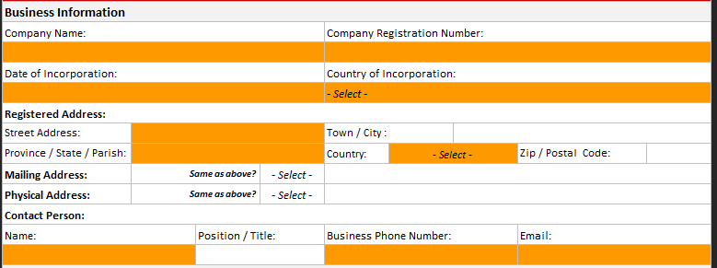

* Beneficial Ownership Information

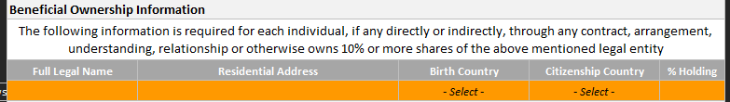

* Business Profile

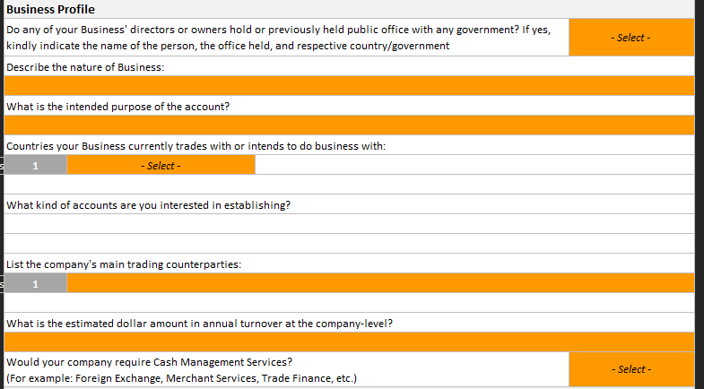

* Business Activity

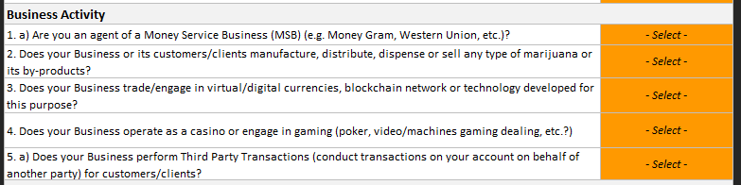

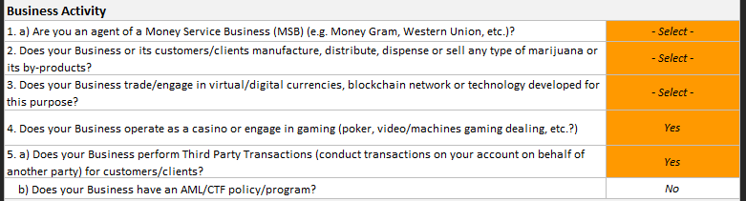

* Additional Information

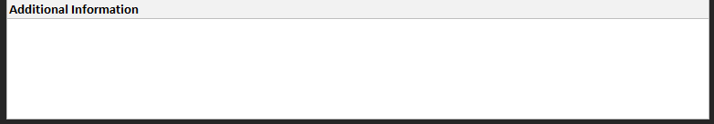

## Appendix B: Internal-Facing EDD Forms – Screenshots

Note Mandatory fields are highlighted in orange.

* Client Information

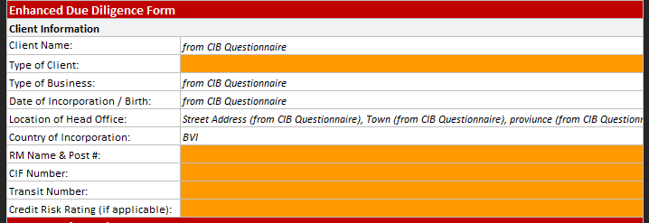

* Account Information

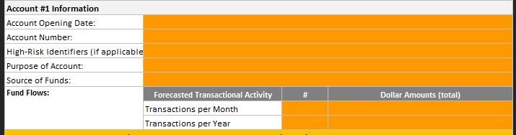

* Client Background

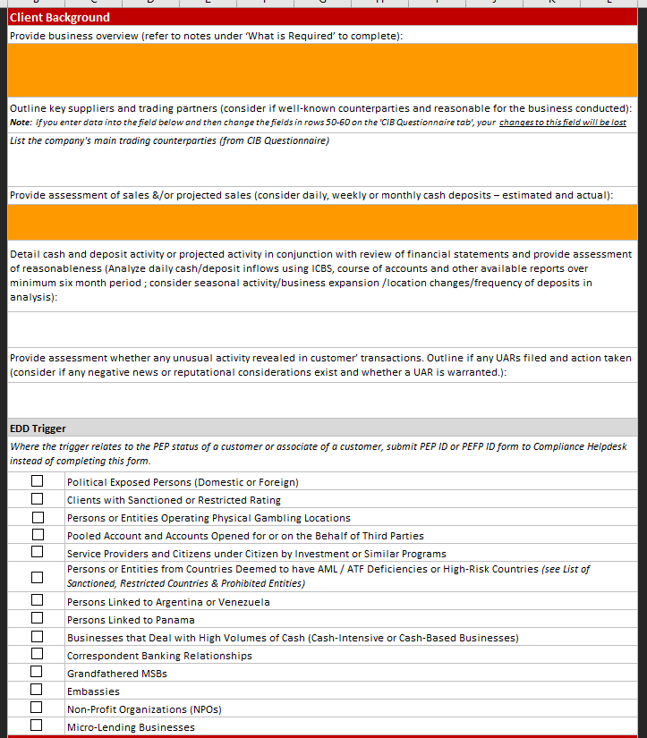

* EDD Trigger

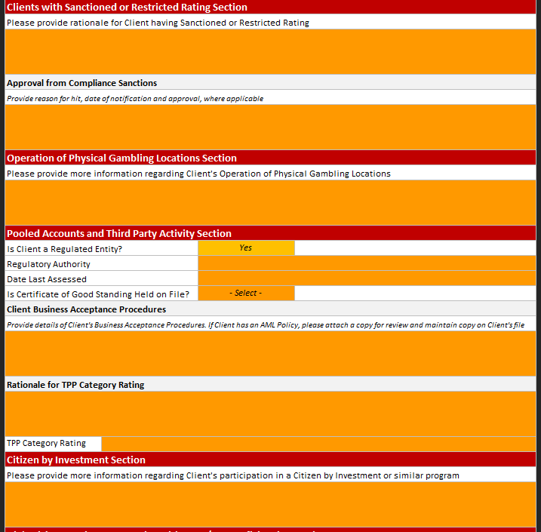

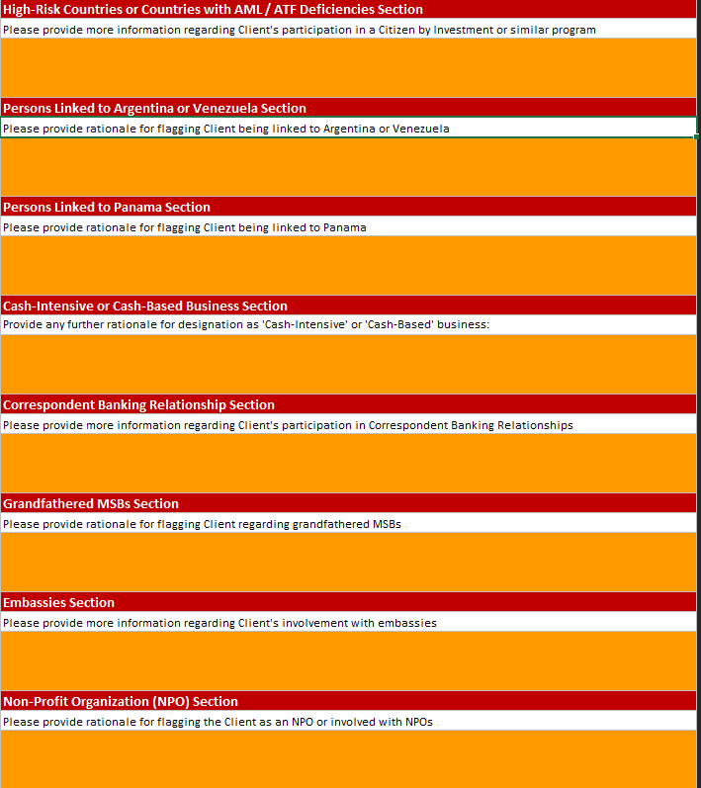

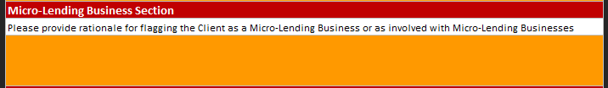

* Business Decision & Controls

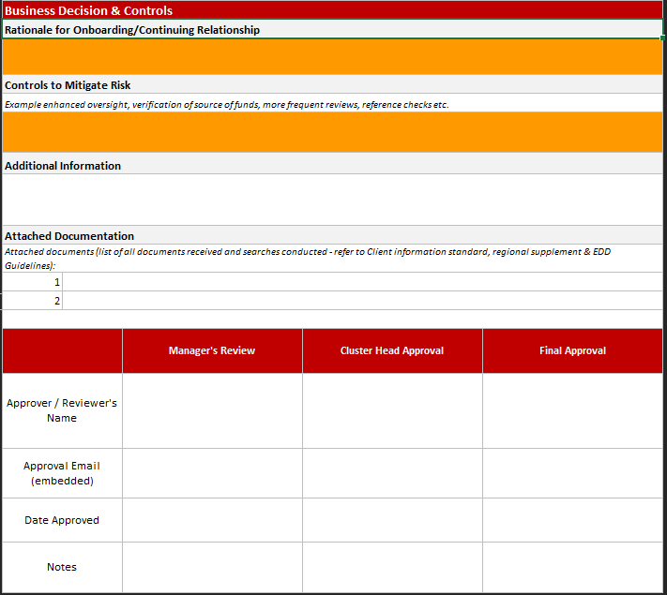

## Appendix C: Sample of PDF Output files

|  |  |
| --- | --- |
| Non-Personal Questionnaire |  |
| Internal-Facing EDD form |  |

## Appendix D: Excel version of Client Risk Profile



## Appendix E: List of material events in triggers

|  |  |
| --- | --- |
|  |  |
| Refer to section **4.1.3.5** from AML/ATF standard |  |

Below is the summary of the material events:

|  |  |  |
| --- | --- | --- |
| **Material event** | **Trigger/Review** | **Comment** |
| Change in the Client risk rating | Automatic/Full |  |
| Change in the level of ML/TF risk for any customer where directed by Compliance due to a change in the AML/ATF Risk Rating Matrix | Automatic/Full |  |
| Where a Risk Event report was completed | Automatic/Full | Let the reviewer to decide to continue with the review or decide that the review is not required. |
| Dormant accounts that are being reactivated | Automatic/Full |  |
| A change in the Client’s name (including changes resulting from the addition or deletion of an Account holder) or a change in the name in which the Account is maintained | Automatic/Full |  |
| A change of a Director or Signing Officer on the Account, including where the Signing Officer is added by virtue of granting of Power of Attorney on an Account, or where the estate representative takes over control of the assets of a deceased individual and becomes a Signing Officer on an Account as a result; | Automatic/Full |  |
| A change/addition of a Beneficial Owner(s) of an Account (Personal or Non-Personal) | Automatic/Full |  |
| The purchase of a new product or attainment of a service by an existing client  * Product can be opening of a new account  * Service can be granting of a credit increase | Automatic/Partial |  |
| Change of residential address outside of country (material change) (also FATCA trigger) | Automatic/Partial |  |
| A transaction which involves or exceeds the prescribed amount and is a material change in the manner in which the account is operated ( applicable to Jamaica); | Manual |  |
| Where transactions conducted appear to be linked (applicable to Jamaica); and m)   Where a transaction is conducted via wire transfer ( applicable to Jamaica) | Manual |  |
| Whenever the LoB has any reason to question the veracity, accuracy, adequacy or currency of any information previously obtained regarding the Client; | Manual |  |
| * Where unusual activity have been noted and reported on an account; (red flag, other than normal activity)  * Where there is a significant change in the way the client account is operated that is not consistent with the client profile.  * If the aggregate amount exceeds the potential activity (inclusive of parameters e.g.  25% consistently over)  * A noticeable or significant increase in the activity on the account e.g. increase in salary deposited (note that the Client profile should be updated to reflect change in account activity once verified); | Manual | The Transaction monitoring process can take care of unusual activity (UAR – Unusual Activity Report - can be filed for various reasons) |
| Negative news and PEP | Manual |  |
| Customer classification | Manual | If change in Customer classification does not lead to Client Risk Rating change, then no review is required. |